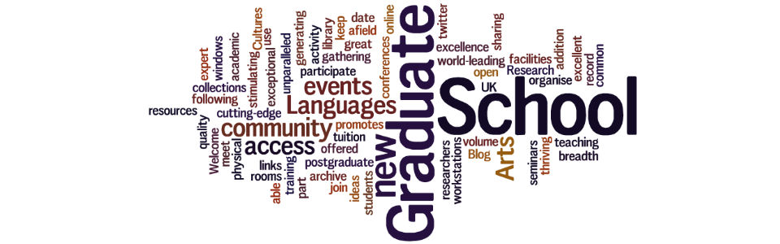
The Graduate School Aid to Publication Award
The Graduate School Aid to Publication Award is a competitive funding scheme designed to assist SALC Postgraduate Researchers with the publication of academic books or articles. Awards of up to £300 each will be allocated this academic year (by 1 April 2019).
Monies may be used to support digitalization of documents to publication standard, publication fees for highly rated Open Access venues, or other publication costs.
To be eligible, researchers need to be currently registered on a PhD programme in the School of Arts, Languages and Cultures. Authors must show evidence that their work is under contract with a publisher or journal and will be published within one year from the date of the application. The scheme has a rolling deadline from now until 1 April 2019 or until the money runs out. Please send a completed application to tine.breban@manchester.ac.uk and amanda.mathews@manchester.ac.uk. Decisions will be communicated to applicants within two weeks of submission.
Successful applicants must recognize the support received from the Graduate School of Arts, Languages and Cultures in the acknowledgement page of the book or in a footnote at the onset of the article. Recipients must notify the Graduate School of the date of publication and will agree that their publication be mentioned in the Graduate School Newsletter and on the Graduate School Webpage.
No application will be considered complete without a formal publication contract (not an advance contract). For a journal article, a message on letter headed paper from the journal editor, specifying the volume and date of publication, will serve as evidence of forthcoming publication.
Name:
Email:
PhD programme:
Supervisors:
Title of Book, Edited Volume, Chapter or Journal Article:
Publisher or Journal/Book:
Name(s) of co-author(s):
Peer-reviewed: Y/N
Open Access: Y/N
Length (total word count including notes, bibliography, etc.):
If applicable, list other sources of funding for this work. Please specify where you have applied, if you are awaiting a decision, or know the outcome of the application.

Disciplines addressed in the work (no more than 200 words):

Aim, scope and methodology of the work (no more than 200 words):

Rationale. Explain in no more than 400 words how the award will help towards the publication of your work:

