Welcome to the Art History Department ‘Decolonising Art History’ newsletter 2020-21

Working closely with our UG and PG students this semester we devised a series of research seminars focusing on the theme of decolonisation.

The 'Decolonising Art History' series forms part of a broader and collective effort by the department to reassess established conceptions of the discipline of art history in the wake of the Black Lives Matter movement and world-wide protests for racial justice during the spring and summer of 2020.

Below is a selection of reports written by our students.

https://manchesterarthistory.wordpress.com/2020/11/23/cloth-turned-people-into-objects-by-molly-lewis/
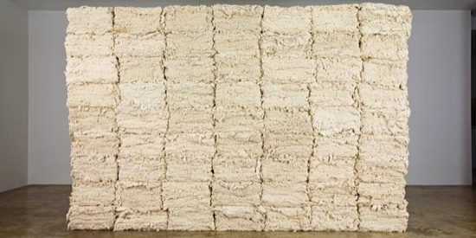 | Cloth turned people into objects by Molly Lewis  Report on the November 2020 Lecture, ‘Vision and Value: Cotton and the Materiality of Race’ by Anna Arabindan-Kesson, assistant professor of Black Diasporic Art, Princeton University Anna Arabindan…  manchesterarthistory.wordpress.com
https://manchesterarthistory.wordpress.com/2020/12/15/whos-laughing-now-humour-as-cultural-resilience-in-contemporary-art-by-janelle-hixon/
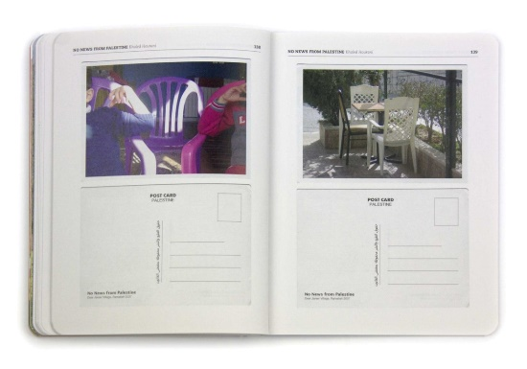 | Who’s Laughing Now: Humour as Cultural Resilience in Contemporary Art by Janelle Hixon  Report on the November 2020 Lecture, ‘Humour and the Commodification of Suffering: Strategies of Cultural Resilience in Contemporary Art’ by Chrisoula Lionis, Marie Curie Fellow, University of Manc…  manchesterarthistory.wordpress.com

https://manchesterarthistory.wordpress.com/2020/11/06/modernity-as-echo-chamber-prof-craig-clunas-on-early-twentieth-century-chinese-art/
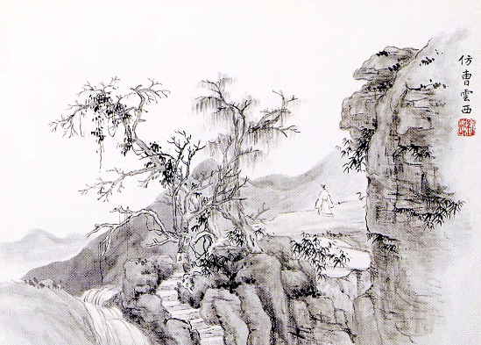 | Modernity as ‘Echo Chamber’: Prof. Craig Clunas on early twentieth-century Chinese art  Report on the 2020 Pilkington Lecture, ‘The Modernity of Chinese Art in the Early Twentieth Century’ by Craig Clunas, Professor Emeritus of the History of Art, Trinity College, Oxford P…  manchesterarthistory.wordpress.com

