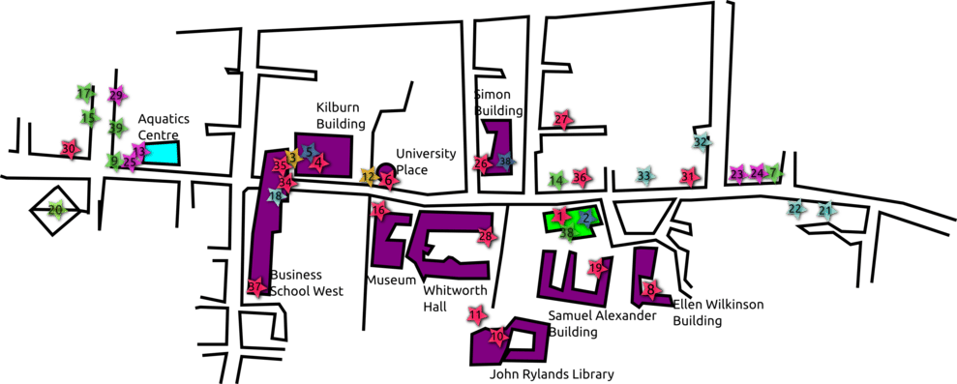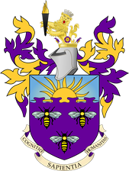

**Student Village: 15 min bus / 40 min walk**

**City Centre: 10 min bus / 30 min walk**

**10 minute bus ride / 20 minute walk**

**Students Union**

University Map:

* How big is your university?
* What buildings do you have?

University Logo:

* University colours
* University crest

Courses taught at your University:

*Traditional/Academic Subjects:*

* *Faculty of Biology, Medicine and Health*
* *Faculty of Humanities*
* *Faculty of Science and Engineering*
* *Student radio and TV*
* *Bar, restaurant, café*
* *Societies (over 400)*
  + *Subject societies, sports, cultural societies, campaigning, arts and performance, etc.*

Activities available at your Students Union:

**University Name:** ***The University of Manchester***

Location: ***Manchester City Centre***

Number of students: ***40,000***