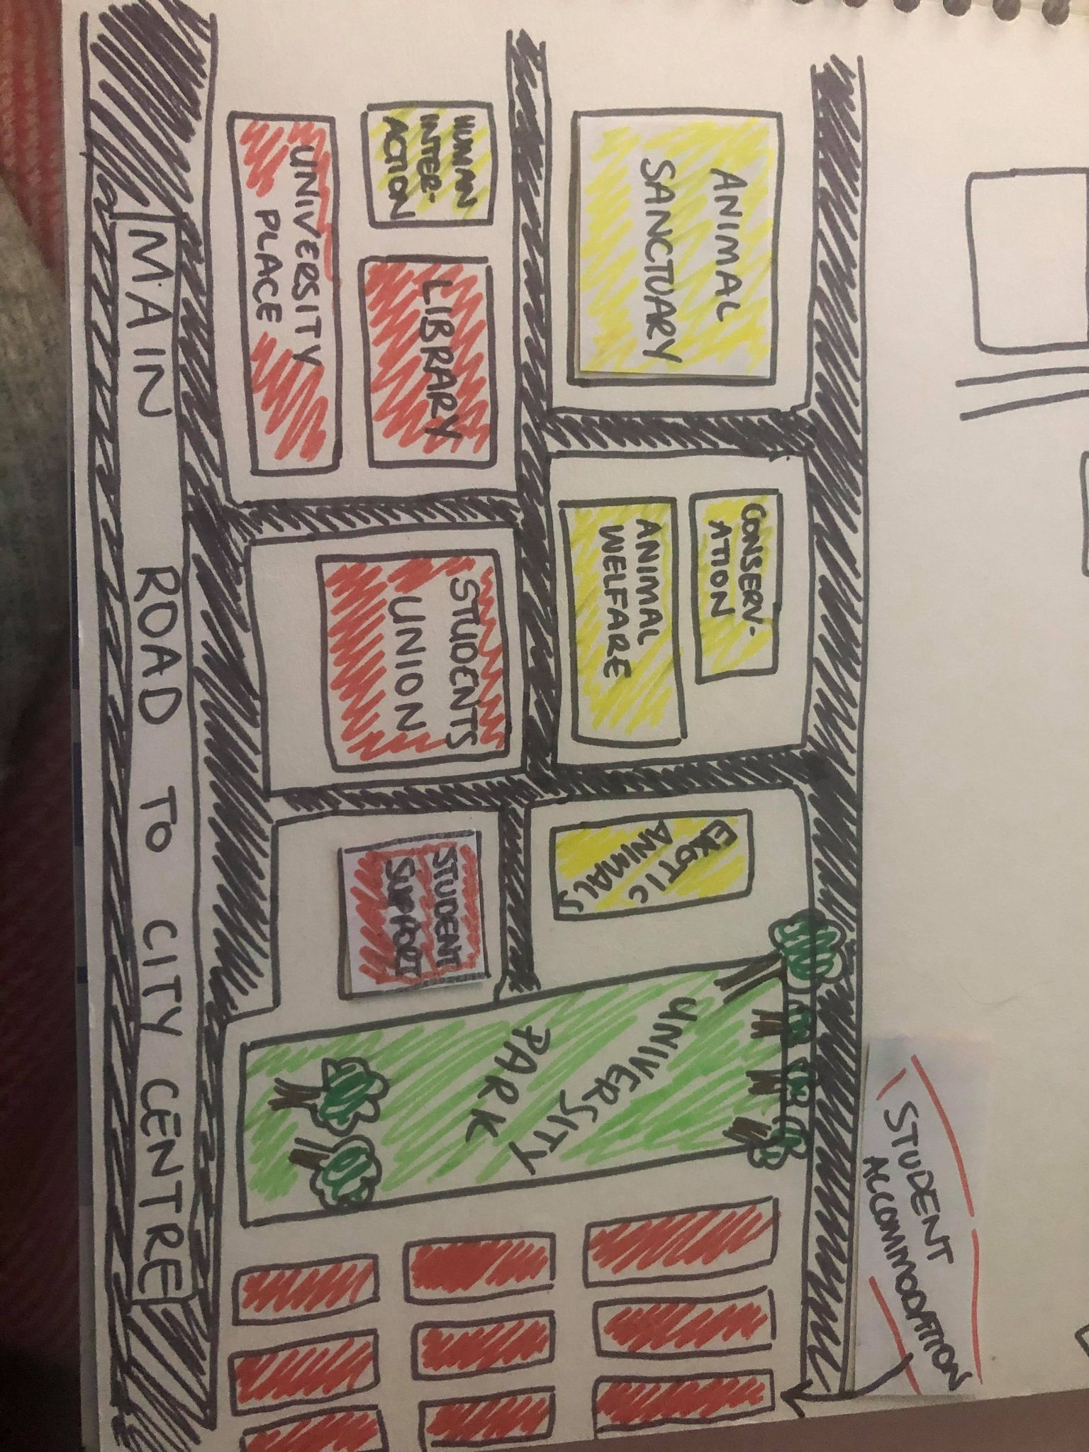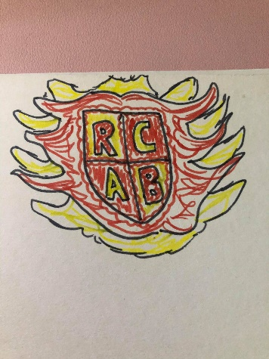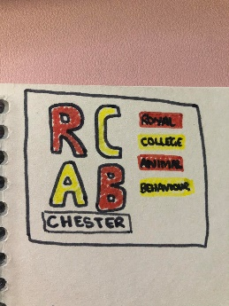

**10 minute walk**

University Map:

* How big is your university?
* What buildings do you have?

**University Name:** ***Royal College of Animal Behaviour***

Location: ***Chester (near Chester Zoo)***

Number of students: ***2,000***

University Logo:

* University colours
* University crest

Courses taught at your University:

* *Animal Behaviour*
* *Animal Behaviour Training*
* *Animal Welfare*
* *Wildlife health and conservation*
* *Animal Nutrition*
* *Human-Animal Interaction and Wellbeing*
* *Exotic Animal Studies*
* *Societies: Sports, religious/cultural, wellbeing, fundraising*
* *Day trips out to see animals: going to the zoo, to farms, coastal places, conservation projects*
* *Campaigning – for animal rights*

Activities available at your Students Union: